Text Sentiment Analysis Using Deep Learning

1. Project Overview
Sentiment analysis is a Natural Language Processing (NLP) technique used to identify the emotional or opinion-based tone of textual data. In this project, an IMDb movie review sentiment analysis system is developed using Python and Deep Learning.
The main objective of the project is to take a movie review as input and automatically classify it as either Positive or Negative based on the language used in the review.
The project follows an end-to-end machine learning workflow:
Data Collection → Data Understanding → Data Preprocessing → Feature Representation → Model Development → Model Optimization → Model Evaluation → Model Comparison → Model Interpretation → Flask Deployment
The project uses multiple neural network architectures, including:
- Artificial Neural Network (ANN)
- Simple Recurrent Neural Network (RNN)
- Long Short-Term Memory (LSTM)
- Gated Recurrent Unit (GRU)
- Bidirectional LSTM (Bi-LSTM)
The models are evaluated using several performance metrics, and the best-performing model is selected for deployment.

2. Problem Statement
Movie review websites contain a large amount of textual information written by users. Manually analyzing thousands of reviews to understand whether users liked or disliked a movie is time-consuming.
Therefore, an automated system is required that can:
- Accept a movie review as input.
- Process and clean the text.
- Convert text into numerical features.
- Use a trained deep learning model to predict sentiment.
- Display the predicted sentiment and confidence.
- Allow multiple reviews to be processed using a CSV file.
- Provide visual analysis and model comparison through a web application.
The proposed system solves this problem using NLP and Deep Learning techniques.

3. Project Objectives
The major objectives of this project are:
- Understand the IMDb movie review dataset.
- Analyze positive and negative sentiment distributions.
- Identify duplicate and missing reviews.
- Analyze review length and frequently occurring words.
- Clean and preprocess raw textual data.
- Convert text into numerical representations.
- Implement TF-IDF as a baseline feature representation.
- Implement tokenization and integer encoding.
- Build multiple deep learning models.
- Compare ANN, RNN, LSTM, GRU, and Bi-LSTM.
- Improve model performance using hyperparameter tuning.
- Evaluate models using different metrics.
- Analyze correctly and incorrectly classified reviews.
- Select the best-performing model.
- Develop an interactive Flask web application.
- Implement single-review prediction.
- Implement batch CSV prediction.
- Provide model comparison and text analytics.
- Document the complete project using GitHub and README.

4. Dataset

IMDb Movie Reviews Dataset
The project uses the IMDb Dataset of 50K Movie Reviews.
The dataset contains 50,000 movie reviews collected from IMDb.
The dataset contains two main columns:
Column | Description
Review | Text of the movie review
Sentiment | Sentiment label of the review
The sentiment contains two classes:
- Positive
- Negative
Originally, the dataset contains approximately:
- 25,000 Positive reviews
- 25,000 Negative reviews
Therefore, the dataset is relatively balanced between the two sentiment classes.

Dataset Link
The dataset was obtained from Kaggle:
IMDB Dataset of 50K Movie Reviews

5. Phase 1 – Data Understanding
The first phase focuses on understanding the dataset before applying any machine learning or deep learning algorithms.

5.1 Understanding the Dataset
The dataset contains movie reviews written in natural language.
For example:
Positive review:
"This movie was absolutely fantastic and I loved every minute of it."
Negative review:
"The story was boring and the acting was terrible."
The objective is to learn the relationship between the words used in a review and its sentiment.

5.2 Dataset Distribution
The IMDb dataset contains approximately equal numbers of positive and negative reviews.
The distribution is approximately:
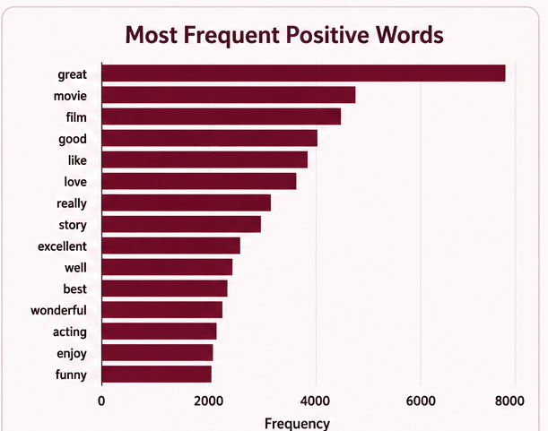
- Positive: 25,000
- Negative: 25,000
This balanced distribution is useful because the model receives a similar amount of training information from both classes.
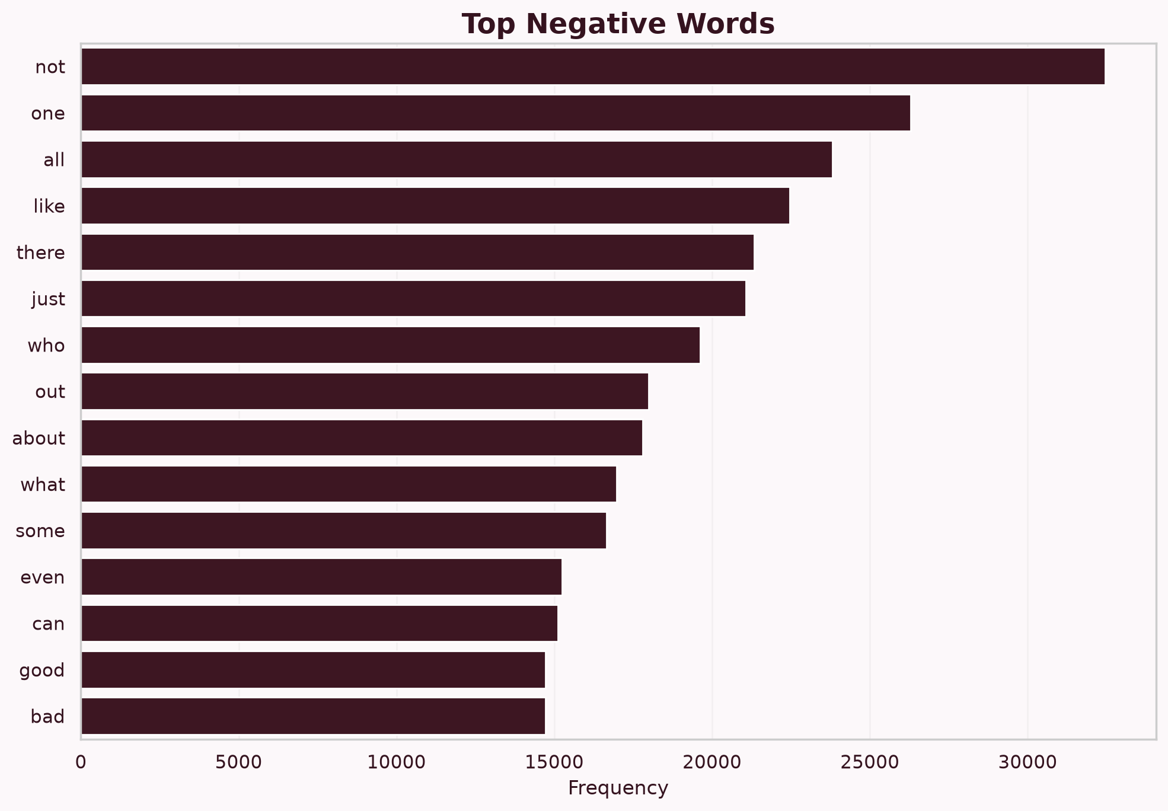
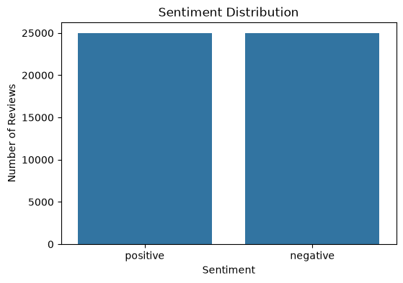

5.3 Missing Value Analysis
Missing values were checked in the dataset.
The analysis showed:
No missing values were found.
This means that the dataset did not require additional handling for missing reviews or sentiment labels.

5.4 Duplicate Review Analysis
Duplicate reviews were also checked.
A total of:
418 duplicate reviews
were identified.
Duplicate records can affect model training because the same review may appear multiple times. Therefore, duplicate reviews were removed before continuing with model development.
Removing duplicates helps improve data quality and prevents the model from learning the same example repeatedly.

6. Review Length Analysis
Review length was analyzed to understand the distribution of short and long reviews.
The number of words in each review can provide useful information about the dataset.
For example:
- Short reviews contain fewer words.
- Long reviews contain more detailed opinions.
- Long reviews may contain both positive and negative statements.
A review length distribution visualization was generated using a histogram.
This analysis helps understand the characteristics of the textual data before preprocessing.
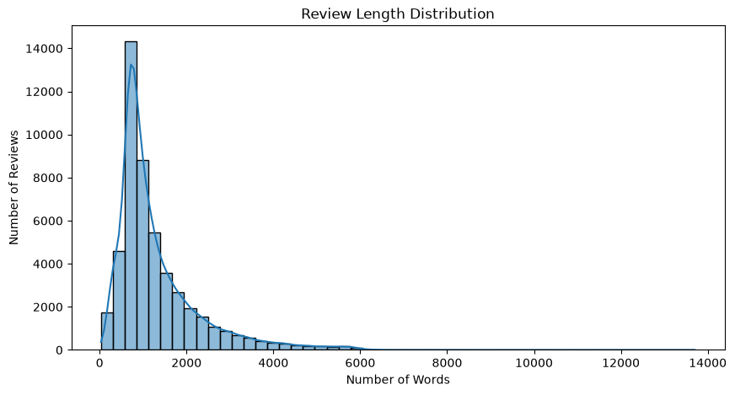

7. Frequently Used Words
Word frequency analysis was performed to identify commonly occurring words in the reviews.
Frequently occurring sentiment-related words include terms such as:

Positive words
- excellent
- amazing
- great
- wonderful
- enjoyable
- fantastic
- brilliant

Negative words
- terrible
- boring
- worst
- poor
- disappointing
- waste
- bad
These words provide an initial understanding of how sentiment is expressed in movie reviews.
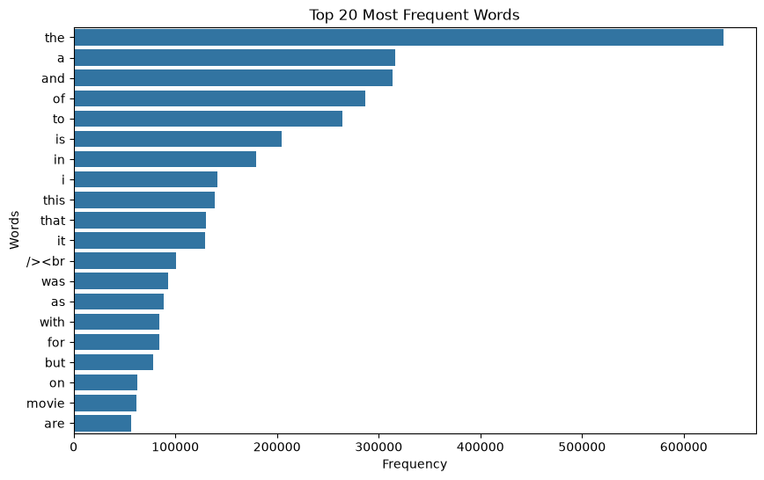

8. Word Cloud
A WordCloud visualization was created to display frequently occurring words.
Words appearing more frequently are displayed more prominently.
The WordCloud provides a quick visual understanding of the vocabulary used in the dataset.
It is useful for exploratory analysis because it allows frequently used words to be identified without examining thousands of reviews individually.
The generated WordCloud was also integrated into the Flask web application's Text Analytics page.
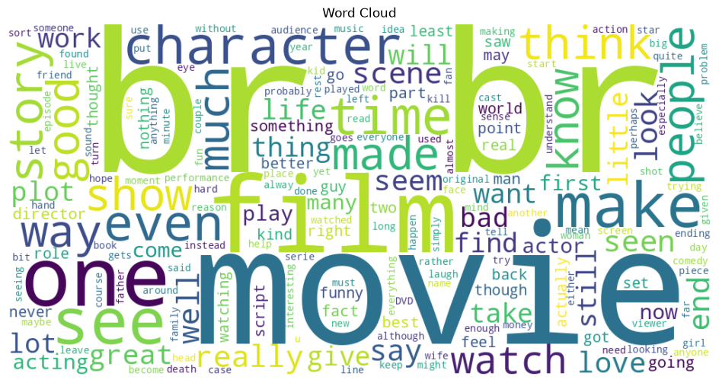

9. Phase 2 – Text Preprocessing
Raw text cannot be directly provided to most deep learning models.
Therefore, the reviews need to be cleaned and transformed into a suitable format.
The preprocessing workflow includes:
Raw Review → Lowercase → HTML Removal → Punctuation Cleaning → Stopword Handling → Tokenization → Integer Encoding → Padding

9.1 Lowercase Conversion
All text was converted into lowercase.
For example:
"This Movie Was AMAZING"
becomes:
"this movie was amazing"
This reduces unnecessary differences between uppercase and lowercase words.

9.2 HTML Tag Removal
Some IMDb reviews contain HTML tags.
For example:
<p>This movie was great</p>
After preprocessing:
this movie was great
HTML tags do not provide useful sentiment information, so they are removed.

9.3 Punctuation Removal
Unnecessary punctuation and special characters were removed.
For example:
"This movie is amazing!!!"
becomes:
this movie is amazing
This simplifies the textual representation.

10. Stopword Handling
Stopwords are commonly occurring words such as:
- the
- is
- a
- an
- this
- was
Stopword handling was applied as part of text preprocessing.
However, sentiment-related negation words such as:
- not
- no
- nor
- never
are important because they can change the meaning of a sentence.
For example:
"This movie is good"
and
"This movie is not good"
have completely different sentiment.
Therefore, important negation words should be preserved.
# Get English stopwords
stop_words = set(stopwords.words("english"))
# Keep important negation words for sentiment analysis
negation_words = {
"no",
"not",
"nor",
"never",
"neither",
"none",
"nobody",
"nothing",
"nowhere",
"hardly",
"scarcely",
"barely",
"isn't",
"wasn't",
"didn't",
"don't",
"can't",
"couldn't",
"won't"
}
# Remove negation words from the stopword list
stop_words = stop_words - negation_words

11. Tokenization
Tokenization converts words into numerical integer IDs.
For example:
"this movie is amazing"
may become something similar to:
[12, 45, 8, 231]
Each word receives an integer index based on the tokenizer vocabulary.
This allows text to be processed by neural networks.

12. Padding and Sequence Creation
Different reviews contain different numbers of words.
For example:
Review 1 → 50 words
Review 2 → 120 words
Review 3 → 200 words
Neural networks generally require inputs with consistent dimensions.
Therefore, sequences were padded to a fixed length.
The padded sequence length used in the project was:
200
The resulting dataset shapes were:
- Training: (34705, 200)
- Validation: (7439, 200)
- Testing: (7438, 200)
Padding makes all reviews have the same input length.

13. Training, Validation and Test Data
The dataset was divided into three parts:

Training Dataset
Used to train the neural networks.

Validation Dataset
Used during training to monitor model performance and identify overfitting.

Test Dataset
Used after training to evaluate the final model on unseen data.
The separation ensures that the model is not evaluated using the same data on which it was trained.

14. Phase 3 – Feature Representation
Machine learning and deep learning models cannot directly understand raw text.
Text must be converted into numerical representations.
The project explored different representations:
- Tokenization + Integer Encoding
- TF-IDF
- Word Embeddings
- Trainable Embedding Layer

15. TF-IDF Representation
TF-IDF stands for:
Term Frequency – Inverse Document Frequency
TF-IDF assigns numerical importance to words based on how frequently they occur in a document and across the complete dataset.
A word that appears frequently in one review but not in many other reviews can receive a higher TF-IDF value.
TF-IDF was used as the baseline representation for the ANN model.
The project used a maximum vocabulary size of approximately:
20,000 features
The generated TF-IDF matrices were saved for later use.

16. Word Embeddings
Word embeddings represent words as dense numerical vectors.
Instead of representing a word as a simple integer, an embedding layer learns relationships between words.
For example, words such as:
- excellent
- amazing
- fantastic
may learn similar vector representations because they are commonly used in similar contexts.
Embedding representations are particularly useful for sequential models such as:
- RNN
- LSTM
- GRU
- Bi-LSTM
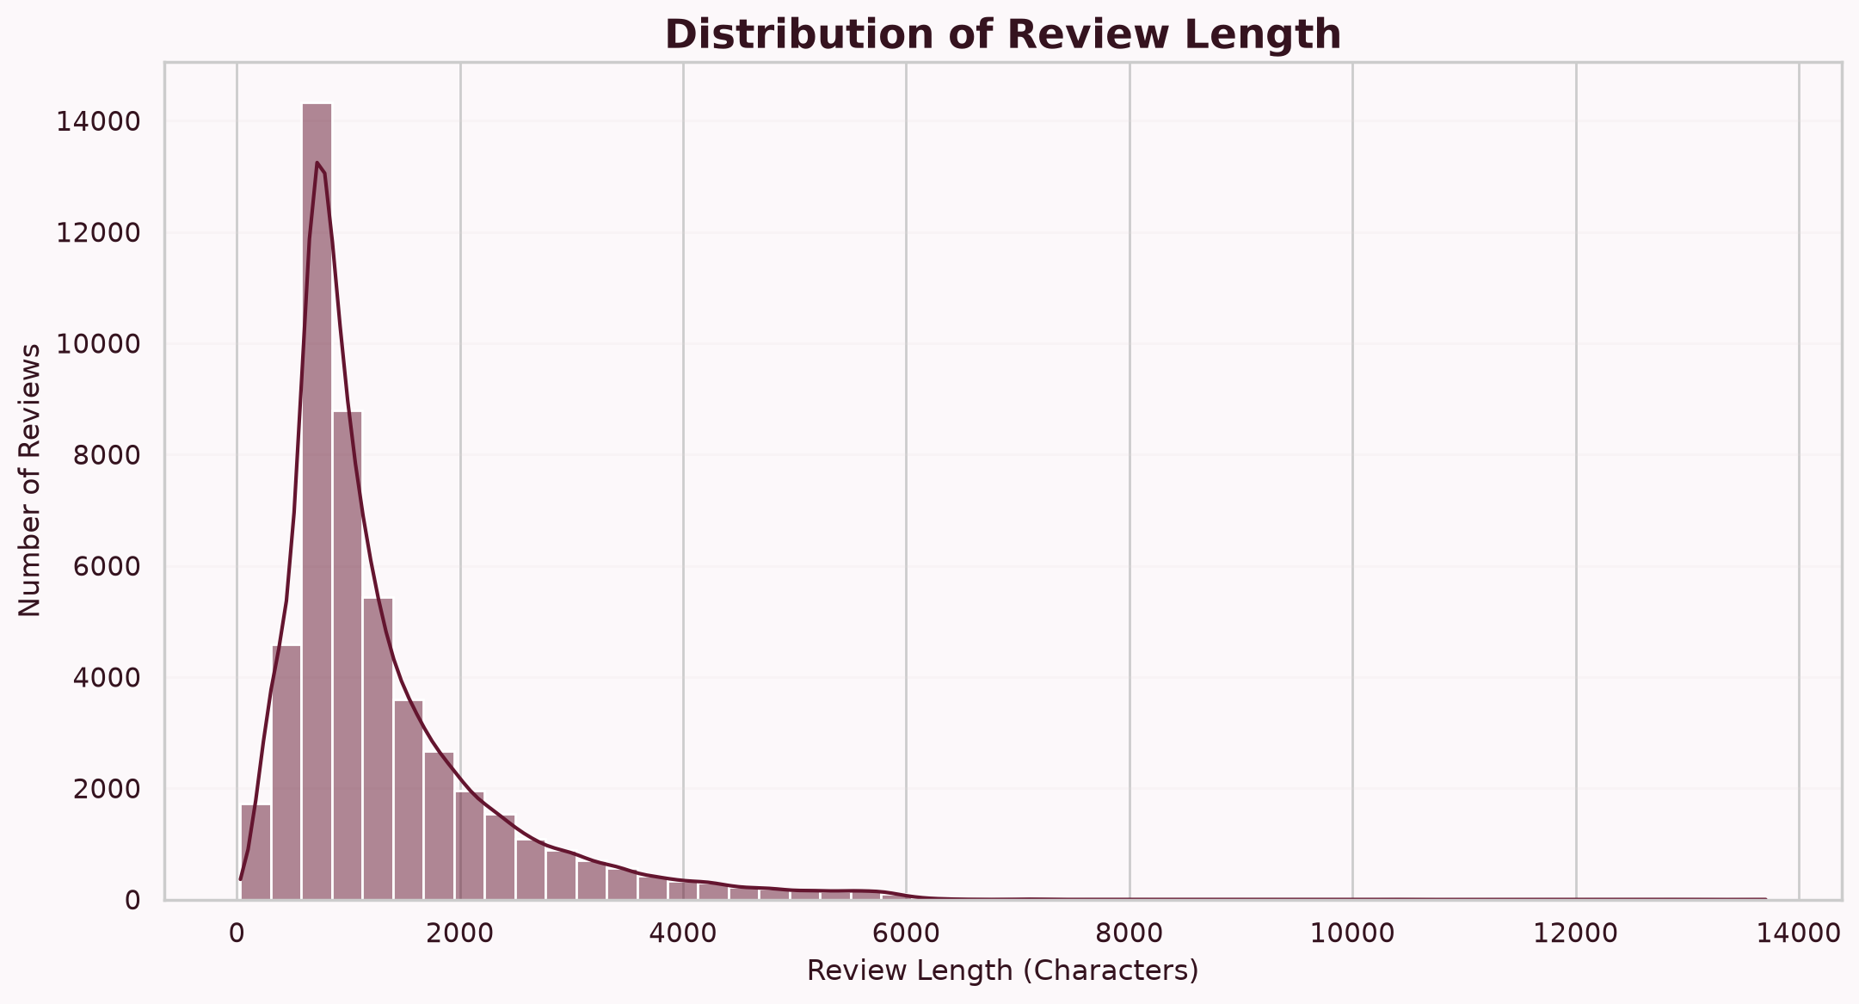

17. Phase 4 – Deep Learning Models
Five different neural network architectures were implemented.
They were:
- ANN
- Simple RNN
- LSTM
- GRU
- Bi-LSTM
Each model was trained and evaluated using the same general sentiment classification objective.

18. Artificial Neural Network – ANN
The ANN model was used as a baseline deep learning model.
The ANN receives numerical features generated from the review text.
The general architecture contains dense layers followed by an output layer.
The output layer predicts the probability of positive sentiment.
For binary classification:
Probability >= 0.5 → Positive
Probability < 0.5 → Negative
The ANN achieved strong performance and was later optimized using techniques such as Early Stopping.

19. Simple RNN
RNN stands for Recurrent Neural Network.
RNNs are designed to process sequential information.
In sentiment analysis, the sequence is the sequence of words in a review.
However, basic RNNs can have difficulty remembering information from long sequences because of problems such as:
- Vanishing gradients
- Difficulty learning long-term dependencies
This was reflected in the relatively lower performance of the RNN model compared with the other architectures.

20. LSTM
LSTM stands for Long Short-Term Memory.
LSTM is an improved form of recurrent neural network designed to learn long-term dependencies.
It uses gates to control information flow:
- Forget gate
- Input gate
- Output gate
This allows the model to remember useful information and discard unnecessary information.
LSTM generally performs better than a basic RNN for longer sequences.

21. GRU
GRU stands for Gated Recurrent Unit.
GRU is another recurrent architecture designed to solve some of the limitations of traditional RNNs.
It uses gating mechanisms to control information flow while having a simpler structure than LSTM.
GRU often provides a good balance between:
- Performance
- Training speed
- Model complexity
In the project, GRU produced performance close to the ANN and achieved strong sentiment classification results.

22. Bidirectional LSTM
Bi-LSTM processes the sequence in both directions:
- Forward direction
- Backward direction
This allows the model to use information from both previous and following words.
For example, understanding a word may depend on words appearing both before and after it.
Therefore, Bi-LSTM can capture richer contextual information than a standard one-directional LSTM.
s.no | Model | Accuracy | Precision | Recall | F1 Score | ROC-AUC
0 | GRU | 0.869320 | 0.864537 | 0.877043 | 0.870745 | 0.938733
1 | RNN | 0.503227 | 0.531046 | 0.087061 | 0.149597 | 0.502507
2 | LSTM | 0.862866 | 0.856505 | 0.873024 | 0.864686 | 0.928980
3 | GRU | 0.875908 | 0.885989 | 0.863916 | 0.874814 | 0.940158
4 | Bi-LSTM | 0.872681 | 0.856084 | 0.897134 | 0.876128 | 0.929282

23. Phase 5 – Model Improvement
After building the baseline models, model optimization was performed.
The objective was to improve generalization and reduce overfitting.
The following techniques were considered:
- Embedding dimension tuning
- Sequence length tuning
- Hidden unit tuning
- Dropout
- Recurrent dropout
- Batch normalization
- Optimizer selection
- Learning-rate tuning
- Batch-size tuning
- Early stopping
- Learning-rate scheduling

24. Early Stopping
Early Stopping was used to prevent unnecessary training.
During training, validation performance was monitored.
If validation performance stopped improving for a specified number of epochs, training was automatically stopped.
This helps prevent overfitting and can reduce training time.
The optimized ANN model using Early Stopping was saved as the best ANN model.

25. Learning Rate
The learning rate controls how much the model's weights are updated during training.
A learning rate that is:
- Too high → training may become unstable.
- Too low → training may become very slow.
Different learning-rate values were tested during optimization.
The optimization process helped identify suitable learning rates for the models.

26. Dropout
Dropout is a regularization technique.
During training, randomly selected neurons are temporarily ignored.
This prevents the model from depending too heavily on specific neurons.
Dropout can therefore help reduce overfitting and improve generalization.

27. Batch Normalization
Batch Normalization normalizes intermediate activations during training.
It can make training more stable and sometimes improve convergence.
It was considered as one of the model optimization techniques.

28. Optimizers
An optimizer controls how the model updates its weights based on the calculated loss.
The project used the Adam optimizer for model training and optimization.
Adam is widely used in deep learning because it adapts the learning rate for individual parameters and generally provides efficient training.

29. Phase 6 – Model Evaluation
After training, each model was evaluated using multiple metrics.
The main metrics were:
- Accuracy
- Precision
- Recall
- F1 Score
- ROC-AUC
- Confusion Matrix
Using multiple metrics provides a more complete understanding of model performance.

30. Accuracy
Accuracy represents the percentage of predictions that were correct.
Formula:
Accuracy =
Correct Predictions / Total Predictions
A higher accuracy indicates that the model correctly classified more reviews.

31. Precision
Precision measures how many reviews predicted as positive were actually positive.
It is useful for understanding the reliability of positive predictions.

32. Recall
Recall measures how many actual positive reviews were correctly identified by the model.
A high recall means the model successfully detects most positive reviews.

33. F1 Score
F1 Score combines Precision and Recall.
It is useful when both precision and recall are important.
The F1 score provides a balanced measurement of classification performance.

34. ROC-AUC
ROC-AUC measures how well the model separates the two sentiment classes across different classification thresholds.
A value closer to 1 indicates stronger classification ability.
The models achieved high ROC-AUC values except for the basic RNN.

35. Confusion Matrix
A confusion matrix shows the relationship between actual and predicted classes.
For binary sentiment classification, it contains:
- True Positive
- True Negative
- False Positive
- False Negative
The confusion matrix helps identify the types of mistakes made by the model.

36. Training and Validation Curves
Training and validation accuracy were plotted to understand model learning.
Similarly, training and validation loss were plotted.
These graphs help identify:
- Underfitting
- Overfitting
- Good generalization
- Training instability
For example, if training accuracy continues increasing while validation accuracy stops improving, the model may be overfitting.

37. ROC Curve
The ROC curve was generated to visualize model classification performance at different thresholds.
The area under the ROC curve is represented by ROC-AUC.
A curve closer to the ideal upper-left region indicates better classification performance.
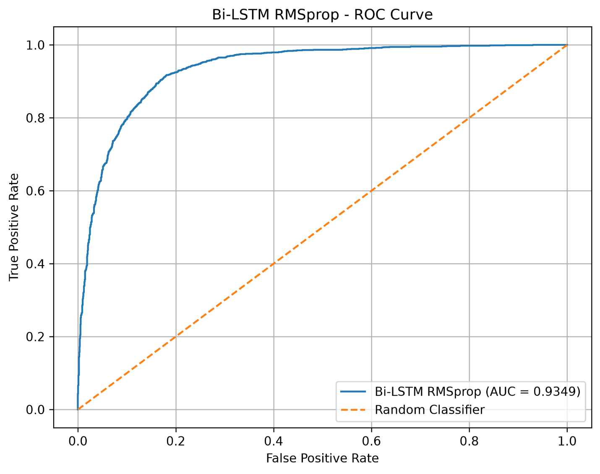

38. Precision-Recall Curve
The Precision-Recall curve shows the relationship between precision and recall at different classification thresholds.
It is useful for understanding the model's ability to maintain precision while increasing recall.
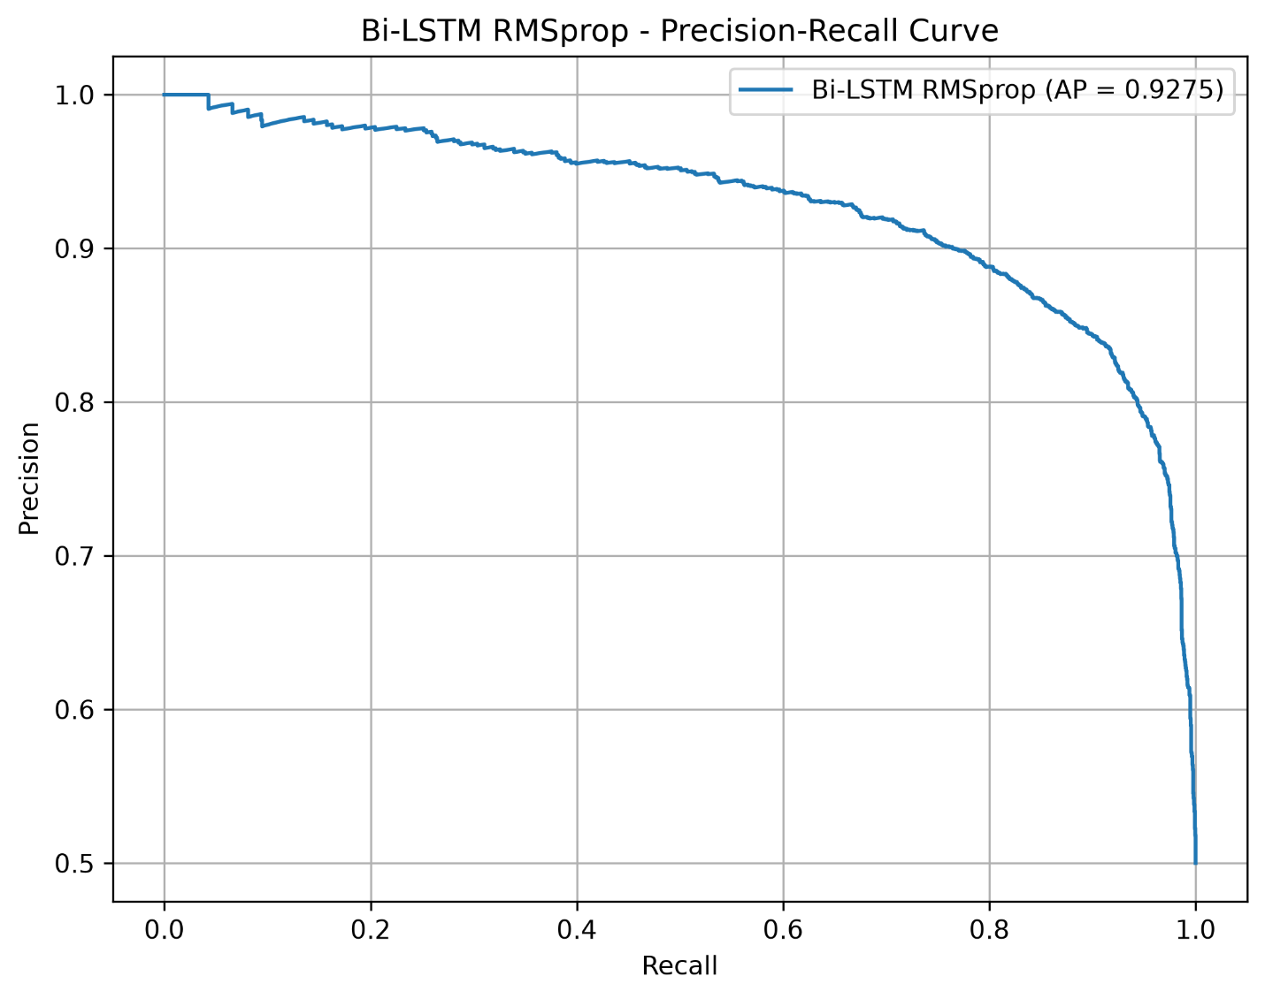

39. Misclassified Reviews
Reviews that were incorrectly classified were analyzed.
Misclassification can occur because reviews may contain:
- Mixed opinions
- Sarcasm
- Irony
- Ambiguous expressions
- Conflicting positive and negative words
For example:
"The acting was excellent, but the movie itself was extremely boring."
This review contains both positive and negative sentiment, making classification more difficult.

40. Phase 7 – Model Comparison
The models were compared using:
Model | Accuracy | Precision | Recall | F1 Score | ROC-AUC
BI-LSTM | 89.43% | 89.26% | 89.74% | 89.50% | 96.05%
GRU | 53.79% | 56.71% | 33.51% | 42.13% | 54.65%
LSTM | 88.25% | 87.49% | 89.37% | 88.42% | 94.48%
RNN | 89.28% | 90.64% | 87.70% | 89.15% | 95.77%
ANN | 87.93% | 89.81% | 85.67% | 87.69% | 94.82%
Based on the provided test results, the ANN achieved the highest accuracy and ROC-AUC, while the GRU achieved the highest precision.
Therefore, the optimized ANN was selected as the final deployed model.

41. Phase 8 – Model Interpretation
Model interpretation helps understand how the model makes sentiment predictions.

Important Words
The model learned patterns associated with sentiment.

Positive language
- excellent
- amazing
- fantastic
- wonderful
- enjoyable
- great
- brilliant

Negative language
- terrible
- boring
- worst
- poor
- disappointing
- waste
- bad
These words provide useful sentiment signals.

42. Correctly Classified Reviews
Most reviews were correctly classified by the stronger models.
Correct classifications indicate that the model successfully learned meaningful relationships between review text and sentiment.
For example:
"The movie was fantastic and the performances were excellent."
The model can identify words such as fantastic and excellent as strong positive indicators.

43. Misclassified Reviews
Some reviews were incorrectly classified.
Common reasons include:

Mixed sentiment
A review may contain both positive and negative opinions.

Sarcasm
For example:
"What a wonderful way to waste two hours."
The word "wonderful" appears positive, but the overall meaning is negative.

Context
Some words change meaning depending on the sentence.

Long reviews
Long reviews may contain many different opinions, making classification more difficult.

44. Model Limitations
The sentiment analysis system has several limitations.

Sarcasm and irony
The model may not understand the hidden meaning behind sarcastic statements.

Mixed sentiment
Reviews containing both positive and negative opinions can be difficult to classify.

Context understanding
Traditional neural models may not fully understand complex language context.

Dataset dependency
Model performance depends on the training dataset.

Domain dependency
A model trained on movie reviews may not perform equally well on:
- Product reviews
- Customer service reviews
- Financial reviews
- Social media posts

45. Effect of Preprocessing and Optimization
Preprocessing plays an important role in sentiment analysis.
Cleaning HTML tags, converting text to lowercase, handling punctuation, tokenizing the text, and padding sequences makes the data suitable for deep learning.
Optimization techniques such as:
- Learning-rate tuning
- Dropout
- Batch normalization
- Batch-size tuning
- Early stopping
- Learning-rate scheduling
help improve model training and generalization.
The optimized ANN demonstrated strong performance and was selected as the final model.

46. Flask Web Application
After completing model development and evaluation, the final model was integrated into a Flask web application.
The web application provides an interactive interface for users.
The application uses:
- Python
- Flask
- Bootstrap
- TensorFlow/Keras
- Pandas
- NumPy
- Scikit-learn

47. Home Dashboard
The Home Dashboard provides an overview of the project.
It displays:
- Total reviews
- Positive reviews
- Negative reviews
- Model performance
- Project information
The dashboard provides users with a quick understanding of the dataset and model results.
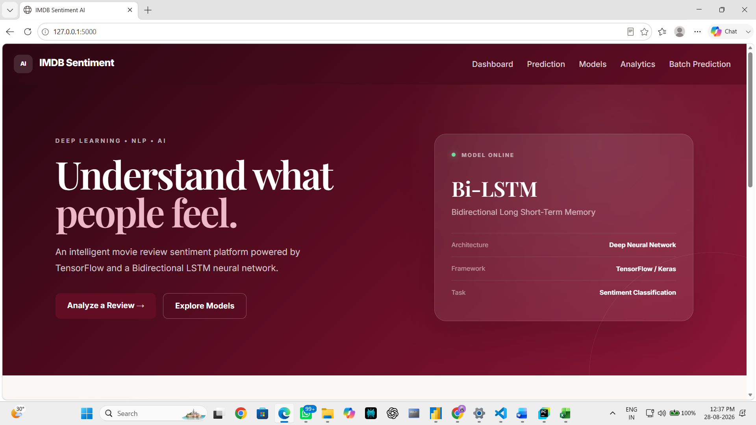

48. Sentiment Prediction Page
The prediction page allows users to enter a movie review.
Example:
This movie was amazing and the acting was excellent.
The application sends the review through the same feature-processing pipeline used during training.
The ANN model then predicts the sentiment.
The page displays:
- Predicted sentiment
- Prediction confidence
- Positive probability
- Negative probability
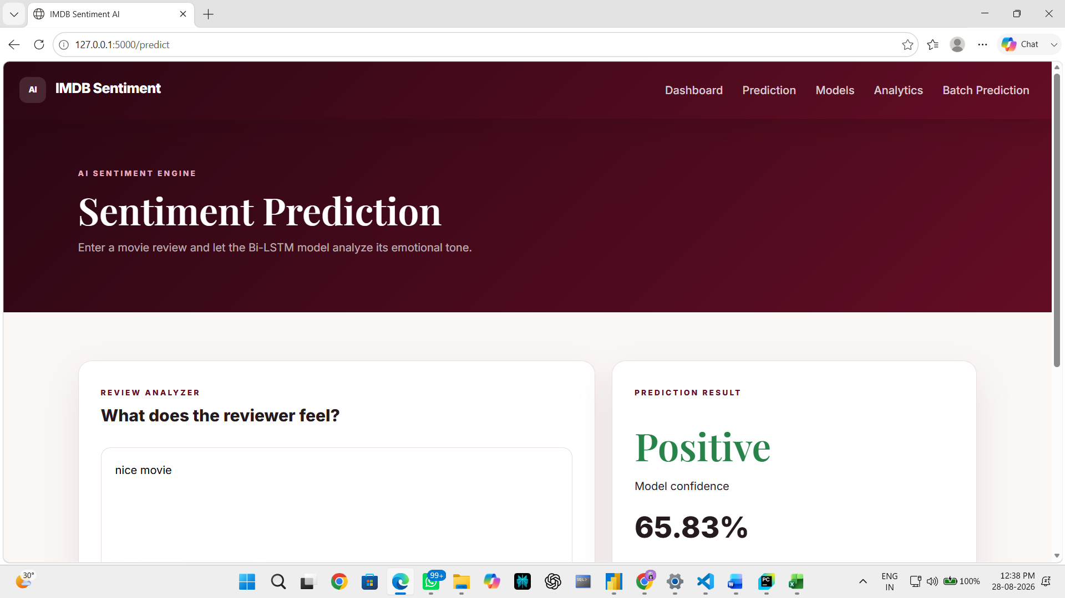

49. Probability Visualization
The application displays sentiment probabilities using progress bars.
For example:
Positive: 92%
Negative: 8%
This allows users to understand not only the predicted class but also how confident the model is.

50. Model Comparison Page
The Model Comparison page displays the performance of:
- ANN
- RNN
- LSTM
- GRU
- Bi-LSTM
The page includes metrics such as:
- Accuracy
- Precision
- Recall
- F1 Score
- ROC-AUC
A model comparison chart is also displayed.
This makes it easier to visually compare the performance of different architectures.
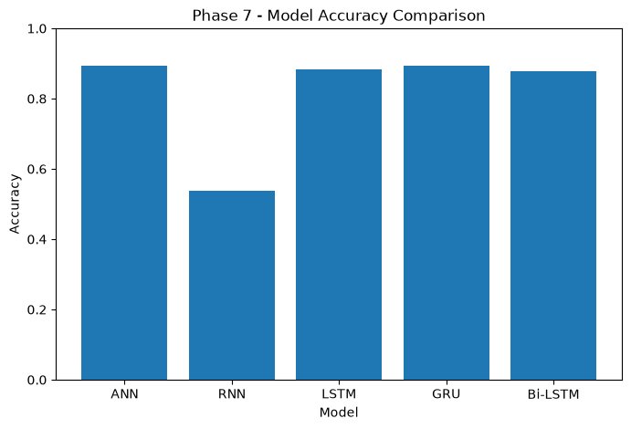

51. Text Analytics Page
The Text Analytics page provides information about the dataset.
It contains:
- Total reviews
- Positive reviews
- Negative reviews
- Sentiment distribution
- Word frequency
- WordCloud
Previously generated visualization images were saved inside the Flask static directory and displayed on the web page.
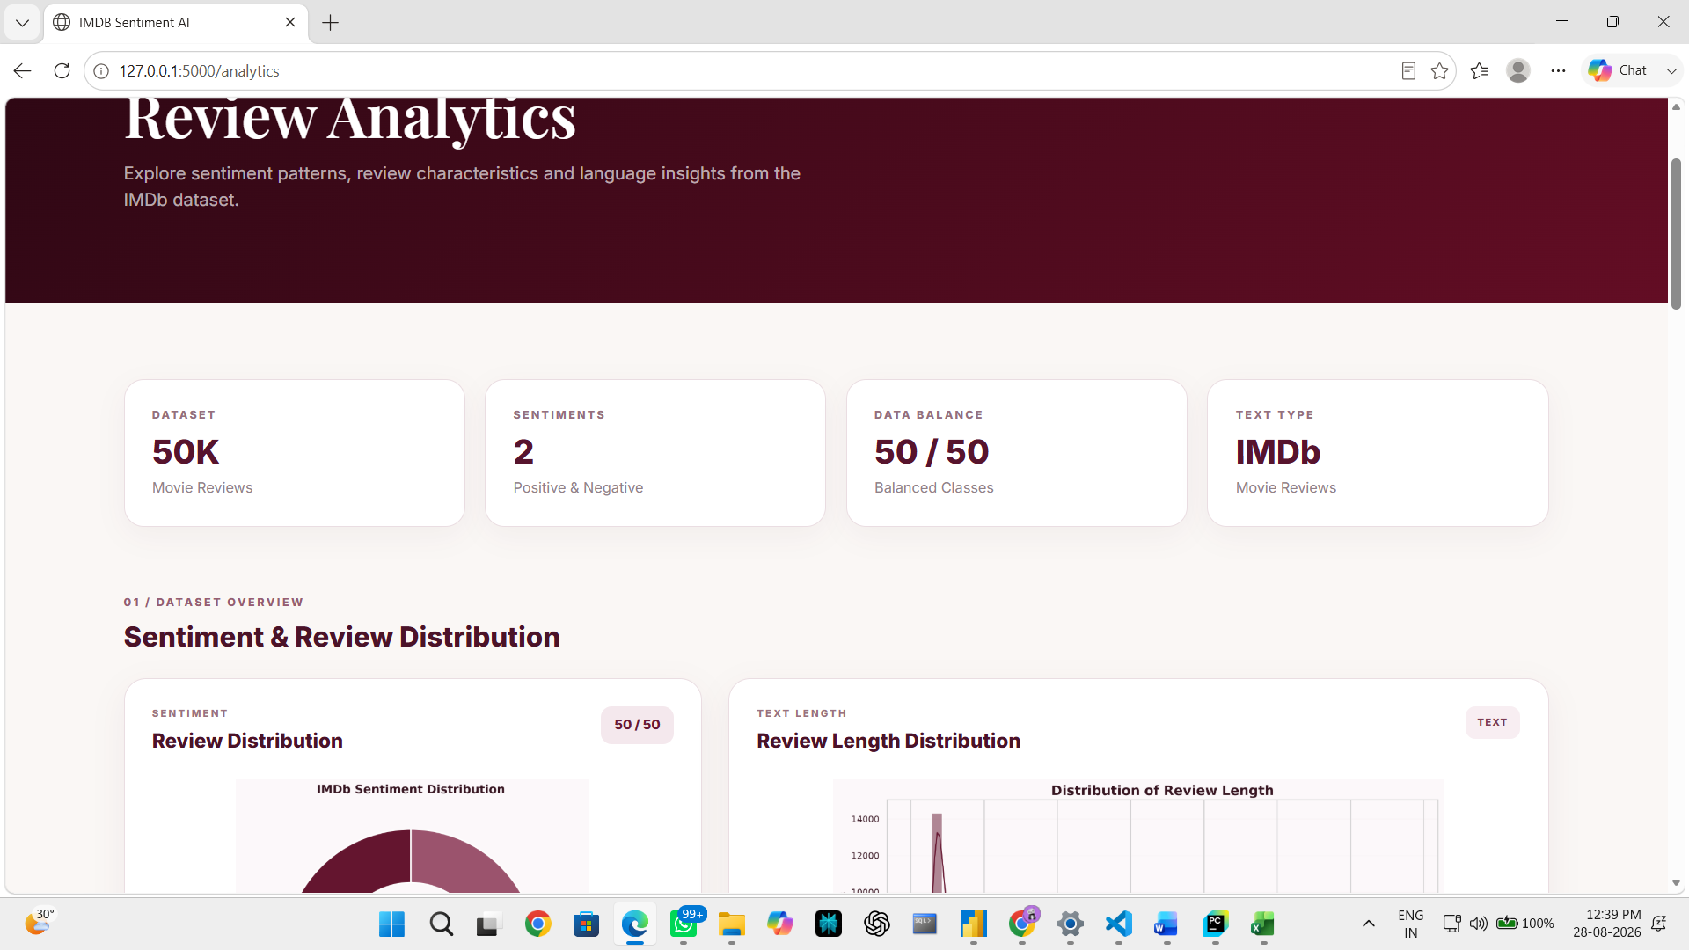

52. Batch Prediction
The Batch Prediction page allows users to upload a CSV file.
The CSV should contain a column named:
Review
For example:
Review
This movie was excellent
The movie was boring
Amazing acting and story
The application processes all reviews and generates predictions.
The output contains:
- Original review
- Predicted sentiment
- Confidence
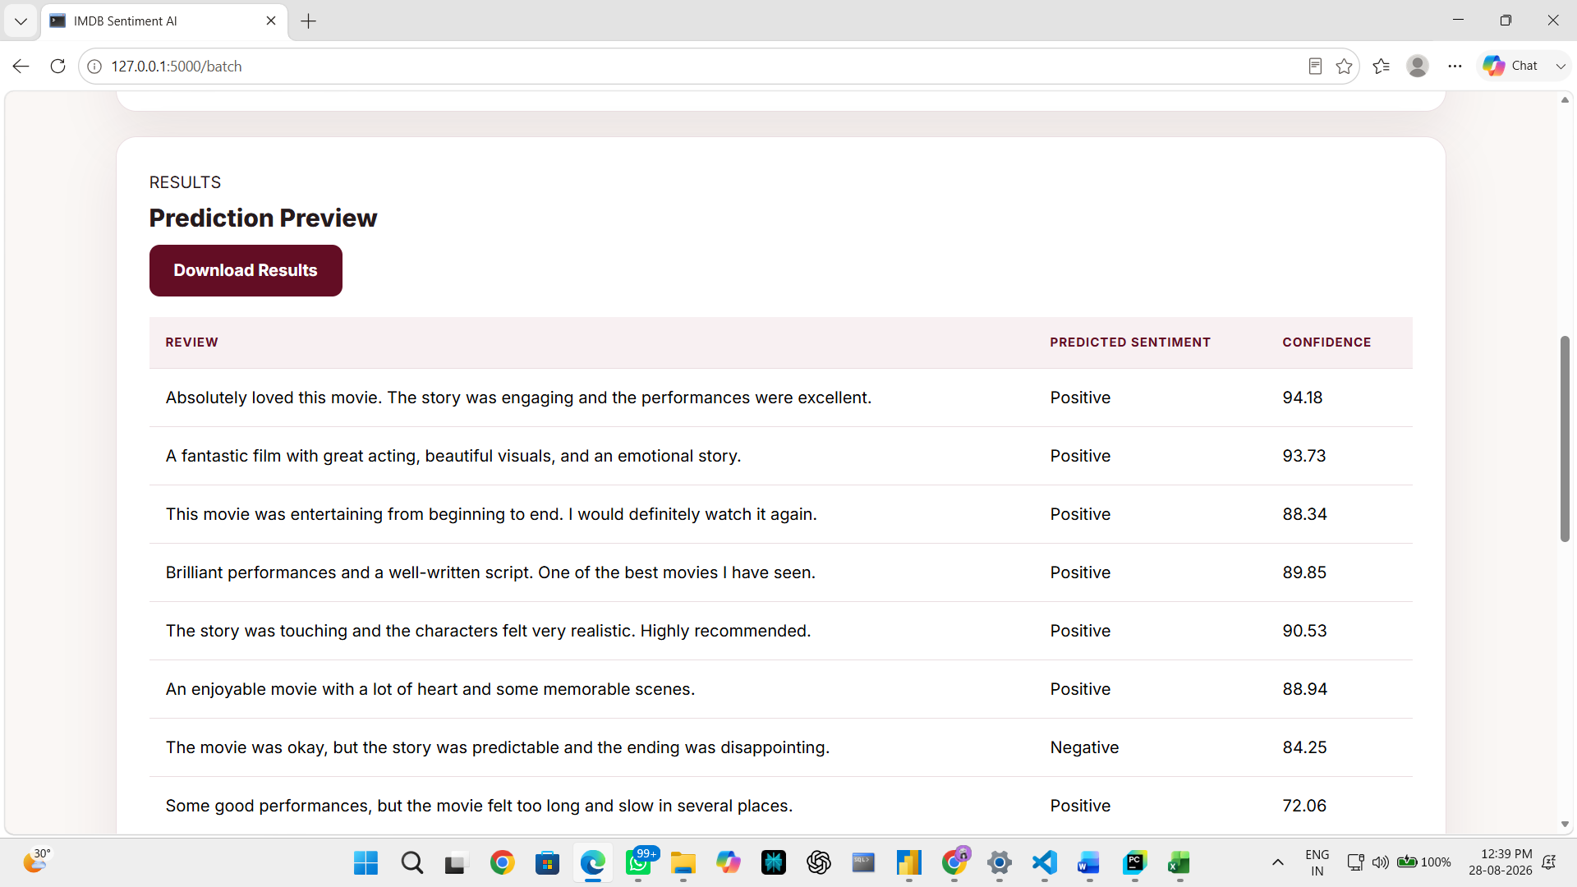

53. Download Prediction Results
After batch prediction, the application creates a new CSV file containing the predictions.
Users can download the generated result file from the web application.
This makes the system useful for analyzing large numbers of reviews at once.

54. Final Conclusion
The project successfully implemented a complete end-to-end text sentiment analysis pipeline, starting from raw IMDb reviews and progressing through preprocessing, feature representation, deep learning model development, optimization, evaluation, interpretation and deployment.
The developed models were systematically compared using Accuracy, Precision, Recall, F1 Score and ROC-AUC. The optimized ANN achieved the best overall recorded performance, while Bi-LSTM was the strongest recurrent architecture.
Finally, the trained model was integrated into a Flask and Bootstrap web application supporting individual and batch sentiment prediction along with model comparison and text analytics.
Overall, the project demonstrates the practical application of Natural Language Processing, Deep Learning, TensorFlow/Keras and Flask to build a complete sentiment analysis system from data preparation to real-world deployment.
Thank You!!

